Chip back potential is the level which bulk silicon is maintained by on-chip connection, or it is the level to which the chip back must be connected when specifically stated below. If no potential is given the chip back should be isolated.

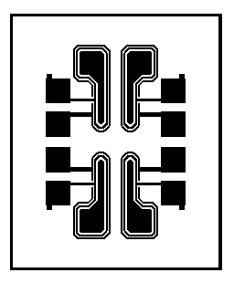
.035”
.043”
D
D
D
D
S
S
S
G
S
G
G
G
SD5000

Top Material: Al
Backside Material: Au
Bond Pad Size: .004” X .004”
Backside Potential: -
Mask Ref: CD2

APPROVED BY: DK DIE SIZE .035” X .043” DATE: 8/25/21
MFG: CALOGIC THICKNESS .009” P/N: SD5501
DG 10.1.2

Rev B, 7/19/02

